Resumption of production with strict control measures and broad support for epidemic prevention

April 6, 2020, Ningbo, China. In view of the improved situation in the prevention and control of the Covid-19 epidemic in China's interior, it is time to accelerate the restoration of order in the everyday life of the population and to resume work processes for the production of essential goods. As a leader in plastic injection molding machinery, Haitian International assumes social responsibility for its employees, society and its suppliers, while strengthening the prevention and control of the epidemic.

Even after resuming production, Haitian International strictly adheres to the principle of "complete prevention and control". For example, we dynamically check the health status of the employees, strictly control the personnel when entering or leaving the factory, and eliminate any hygiene weaknesses in public areas. Our canteens remain closed to avoid large crowds of people, but instead we rely on online offices to reduce the risks as much as possible.

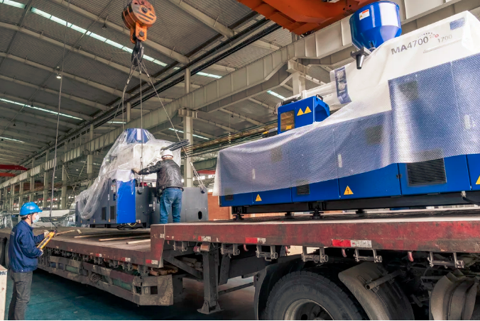
Parallel to the implementation of all preventive measures, we have taken the reins of action. It is necessary to speed up the planning of work resumption and production in the supporting industries, to keep production stable overall and to optimize the annual production plan. Both the delivery of ordered products and the production of urgently needed materials for epidemic containment must be fully guaranteed. One of the priority objectives is to minimize the impact of the epidemic and to create a basis to take advantage of market opportunities once the epidemic has subsided.

More than 4,000 units delivered in one month

Since the resumption of work on February 10, Haitian International has given priority to supporting the production of the materials needed in the front line of epidemic prevention work. In the course of this, we organize preferentially the production and shipment of important materials and products, such as respirators, temperature thermometers, protective goggles, disinfectants, and fast food boxes. The production line of the company is working at full capacity. All employees work overtime to meet the required workload.

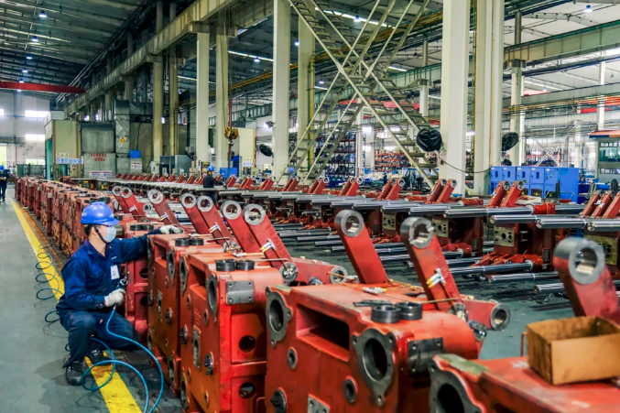
In March, the subsidiary Haitian Plastics Machinery delivered more than 4,000 machines and received orders of nearly 5,000 machines. In times like these, this is a result that gives courage.

Actively leading the way as a production driver

As a leading company in the field of injection molding machines, Haitian International has been confronted with various challenges within the industrial process chain since resuming operations, for example in interregional logistics or due to the insufficient supply of supporting products.

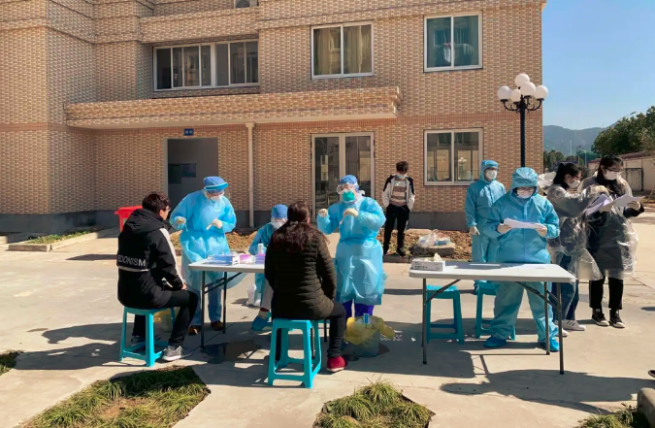
In order to advance and guarantee production, we support the companies of the upstream and downstream market sectors in resuming their work and production. For example, we have established an integrated mode for epidemic prevention and industrial cooperation. At the same time, Haitian International supports the city and district governments in the context of priority assessments on the part of industrial suppliers and process partners.

Since the processing industry is at high risk of infection due to the number of non-local employees, Haitian International has taken the initiative and is financing the nucleic acid test for personnel returning to Ningbo. The smooth implementation of the epidemic prevention work is thus also guaranteed in the supporting companies.

In order to alleviate the current high financial pressure of the supporting companies, Haitian International also made advance payments for the purchase of raw materials in order to support their way back to normal production strength.

Haitian International will continue to keep the safety and well-being of customers, employees and suppliers as our top priority as we follow the path to normal operations.

