Smart Solutions
Intelligent solutions - an opportunity in the crisis

The Covid-19 pandemic is inevitably having a serious impact in a wide range of business sectors. Even some time after the resumption of work and production processes, many companies will still face significantchallenges, be it the insufficient number of returning employees, the reduction of personnel contacts or the impairment of production efficiency. Intelligent production and manufacturing solutions that are less dependent on people are now coming into their own.

Smart Solutions: more flexible than traditional manufacturing

With Smart Solutions in production, companies are more flexible to cope with the current situation. They can resume work more quickly, so they are less affected by the effects of thepandemic.

Smart Solutions not only helps to avoid crowds during the pandemic. They also offer important economic benefits, such as lower production costs and higher efficiency, lower error rates, improved product quality and greater competitiveness. The integration of the intelligent production and information management system will be in great demand in the coming days.

As the saying goes: crisis and opportunity go hand in hand. In this respect, the Covid-19 pandemic will certainly accelerate the transformation of the Chinese and global manufacturing industry into intelligent, unmanned production.

Turnkey solutions from Haitian Smart Solutions

Haitian International is not only committed to producing plastic injection molding machines with excellent performance and quality, but also strives to help customers build environmentally friendly, energy-efficient factories. As part of this commitment, Haitian Smart Solutions, a subsidiary of Haitian International, offers complete intelligent injection molding solutions for this purpose, all from a single source.

The intelligent system planning for injection molding technology includes the centralised supply of raw materials and water systems, the integration and logistics of automation, information on injection molding production and other integrated services.
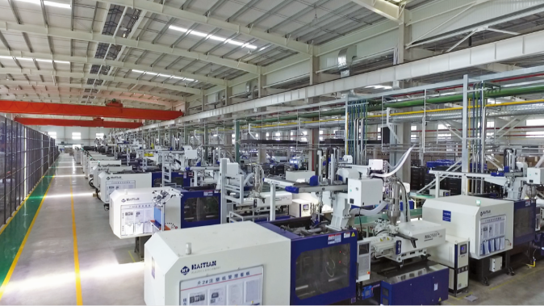
Figure: Haitian Smart Solutions in the automotive industry

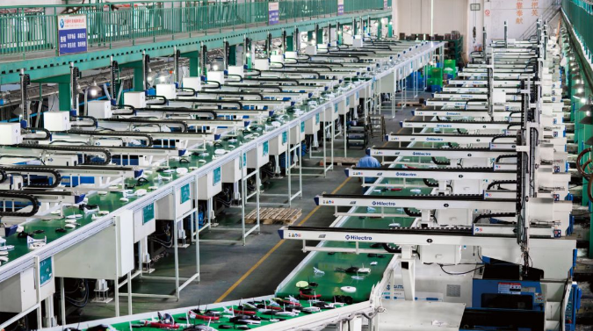
Figure: Application Haitian Smart Solutions in the household appliance industry

Such a turnkey solution has been applied in many industries, including the automotive, logistics, household appliance and toy industries. Many customers have already benefited from the energy-saving, environmentally friendly and highly efficient approach to production.

The entire production process is fully automated. The raw materials are automatically dried and fed to each individual injection molding machine via a central feed system. The products are automatically picked up by robots for machine-side processing and then passed through the conveyor belt, the AGV and other automatic flows. The entire process is highly automated and completely unmanned.

Cost savings, energy savings and increased efficiency are, in the final analysis, the greatest benefits of the intelligent solutions for the customer. They add up to several advantages: much lower labor costs; 24-hour continuous production, higher production efficiency; clean environment at the production site due to the separation of machine and materials; and transparent digital management through Haitian’s "Go Factory" platform.

Haitian Smart Solutions is able to provide customized solutions for each customer, minimizing the cost of the value chain and significantly increasing the customer's competitiveness in the digital age. Haitian Smart Solutions can help companies overcome the COVID-19 crisis.

